Community-based surveillance — template reporting form
Below is a template community-based cholera surveillance reporting form for use in collecting daily aggregate data on individuals meeting the definitions of a suspected cholera case or death in the community.
This form is designed to be customised. In particular, it is recommended that:
- guidance on how to report (see page 4) be added to describe the local procedures in place for community-based surveillance reporting;
- the form be translated into local language(s);
- if reporting according to the age groups listed on the sample form is not possible, at a minimum, reporting should be done for the following age groups: <5 years old, ≥5 years old;
- if Rapid Diagnostic Tests (RDTs) are used in community-based surveillance programmes, information about the number of RDTs performed and RDTs results should be added to the form
Community-based surveillance — template reporting form

Surveillance unit:  ________________________________________________ | Name of community health worker/volunteer:  ________________________________________________
Community/Village:  ________________________________________________ | Telephone number:  ________________________________________________
Date of reporting:
________________________________________________

Date  (YYYY-MM-DD) | Number of suspected cholera cases per day |  |  |  |  |  |  |  |  |  |  |  | Number of community cholera deaths per day |  |  |  |  |  |  |  |  |  |  |  | Number of suspected cholera cases referred to health facilities per day
 | Male  Age groups |  |  |  |  |  | Female  Age groups |  |  |  |  |  | Male  Age groups |  |  |  |  |  | Female  Age groups
 | <2 | [2-4] | [5-14] | [15-44] | [45-59] | ≥60 | <2 | [2-4] | [5-14] | [15-44] | [45-59] | ≥60 | <2 | [2-4] | [5-14] | [15-44] | [45-59] | ≥60 | <2 | [2-4] | [5-14] | [15-44] | [45-59] | ≥60
Total
If no suspected cholera cases or community cholera deaths were detected on a given date, mark “0”.

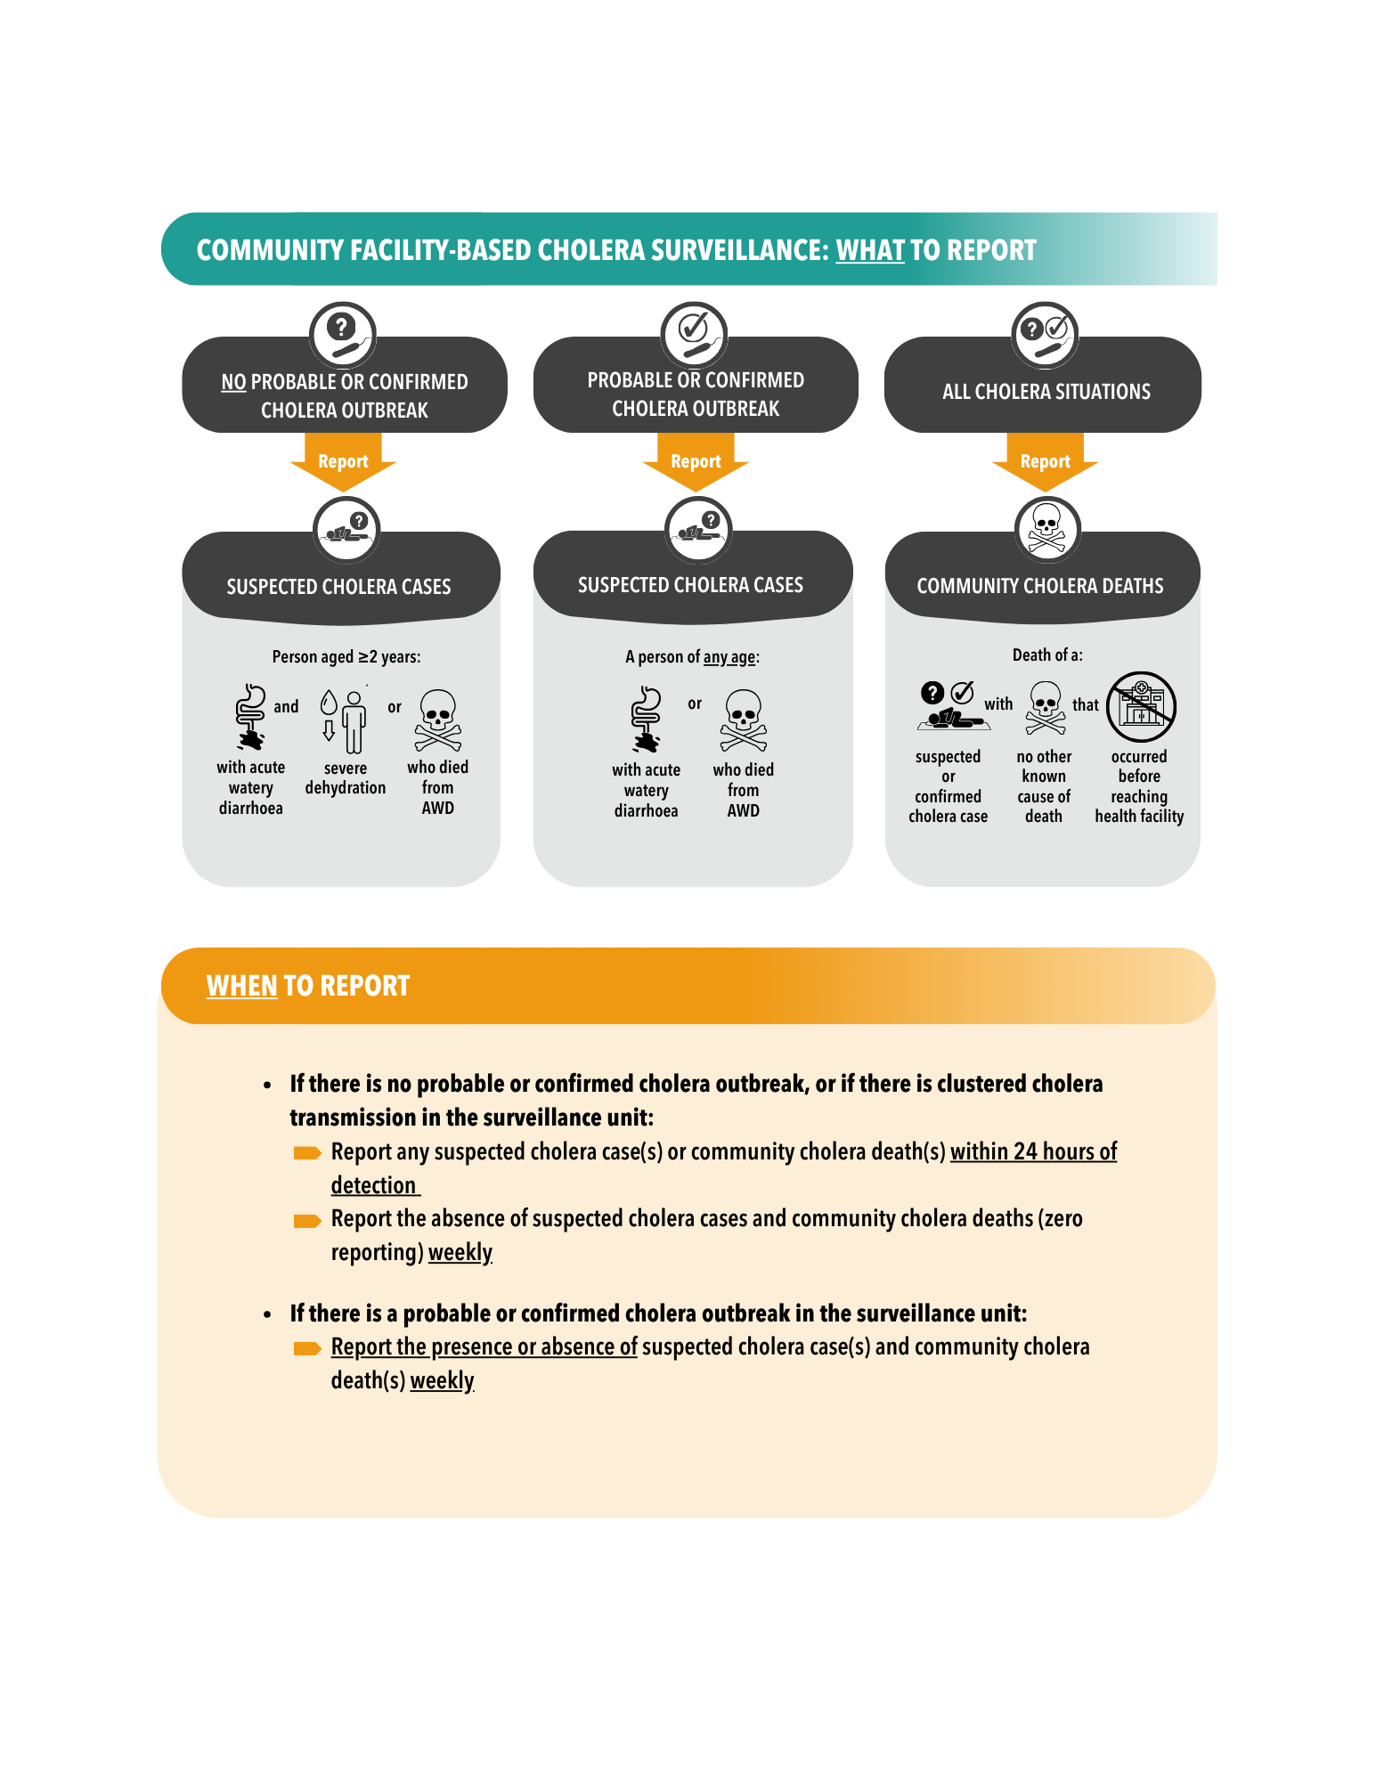
Section to be customised to describe local procedures for reporting community-based cholera surveillance data. <<<CLICK HERE TO EDIT>>

Section to be customised to describe local procedures for reporting community-based surveillance data. <<CLICK HERE TO EDIT>>

